**EtherNet/IP Level 2.06 Count Conditions**

This is a much shorter function to test

Output traffic.

|  |  |  |  |  |  |  |
| --- | --- | --- | --- | --- | --- | --- |
| **Status/Path** | **Access** | **Class** | **Attribute** | **#Out** | **Data Out** | **Raw Out** |
| 32 7A 01 6E | Set | Index | Count_Block | 1 | 1 | 01 |
| 32 67 01 71 | Set | Print_format | Print_Character_String | 9 | "{{CCCC}}" | 7B 7B 43 43 … |
| 32 79 01 67 | Set | Count | Initial_Value | 5 | "0001" | 30 30 30 31 00 |
| 32 79 01 68 | Set | Count | Count_Range_1 | 5 | "0000" | 30 30 30 30 00 |
| 32 79 01 69 | Set | Count | Count_Range_2 | 5 | "9999" | 39 39 39 39 00 |
| 32 79 01 6E | Set | Count | Jump_From | 5 | "6666" | 36 36 36 36 00 |
| 32 79 01 6F | Set | Count | Jump_To | 5 | "7777" | 37 37 37 37 00 |
| 32 79 01 6C | Set | Count | Increment_Value | 1 | 1 | 01 |
| 32 79 01 6D | Set | Count | Direction_Value | 1 | Up | 01 |
| 32 79 01 73 | Set | Count | Zero_Suppression | 1 | Enable | 01 |
| 32 79 01 74 | Set | Count | Count_Multiplier | 2 | "2" | 32 00 |
| 32 79 01 70 | Set | Count | Reset_Value | 5 | "0001" | 30 30 30 31 00 |
| 32 79 01 75 | Set | Count | Count_Skip | 2 | "0" | 30 00 |
| 32 79 01 6A | Set | Count | Update_Unit_Halfway | 3 | 0 | 00 00 00 |
| 32 79 01 6B | Set | Count | Update_Unit_Unit | 3 | 1 | 00 00 01 |
| 32 79 01 71 | Set | Count | Type_Of_Reset_Signal | 1 | Signal 1 | 01 |
| 32 79 01 72 | Set | Count | External_Count | 1 | Disable | 00 |

Input Traffic.

|  |  |  |  |  |  |  |
| --- | --- | --- | --- | --- | --- | --- |
| **Status/Path** | **Access** | **Class** | **Attribute** | **#In** | **Data In** | **Raw In** |
| 33 79 01 66 | Get | Count | Number_Of_Count_Block | 1 | 1 | 01 |
| 33 79 01 67 | Get | Count | Initial_Value | 4 | "0000" | 30 30 30 30 |
| 33 79 01 68 | Get | Count | Count_Range_1 | 4 | "0000" | 30 30 30 30 |
| 33 79 01 69 | Get | Count | Count_Range_2 | 4 | "9999" | 39 39 39 39 |
| 33 79 01 6A | Get | Count | Update_Unit_Halfway | 3 | 0 | 00 00 00 |
| 33 79 01 6B | Get | Count | Update_Unit_Unit | 3 | 1 | 00 00 01 |
| 33 79 01 6C | Get | Count | Increment_Value | 1 | 1 | 01 |
| 33 79 01 6D | Get | Count | Direction_Value | 1 | Up | 01 |
| 33 79 01 6E | Get | Count | Jump_From | 4 | "6666" | 36 36 36 36 |
| 33 79 01 6F | Get | Count | Jump_To | 4 | "7777" | 37 37 37 37 |
| 33 79 01 70 | Get | Count | Reset_Value | 4 | "0001" | 30 30 30 31 |
| 33 79 01 71 | Get | Count | Type_Of_Reset_Signal | 4 | 808464433 | 30 30 30 31 |
| 33 79 01 72 | Get | Count | External_Count | 0 | Disable |  |
| 33 79 01 73 | Get | Count | Zero_Suppression | 1 | Enable | 01 |
| 33 79 01 74 | Get | Count | Count_Multiplier | 1 | "2" | 32 |
| 33 79 01 75 | Get | Count | Count_Skip | 1 | " " | 20 |

Browser screen

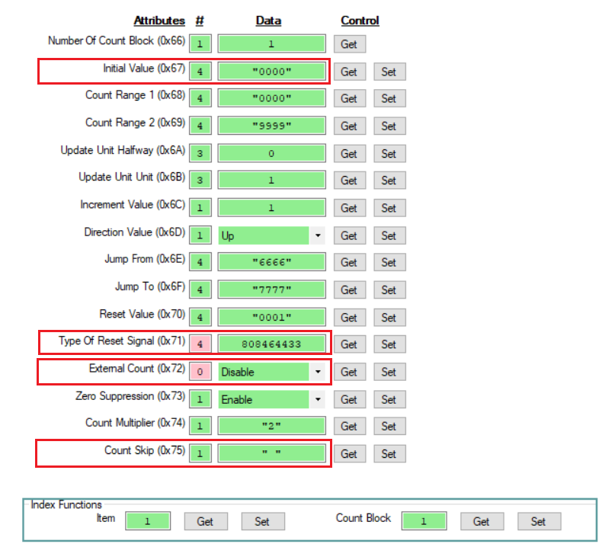

Test Results:

* Initial Value == Returned as 0, not 1.
* External Signal was returned as a character string, not a decimal value
* External count returned no data
* Skip count was returned as a space.